

ChimneyRidge

2022 FACT SHEET

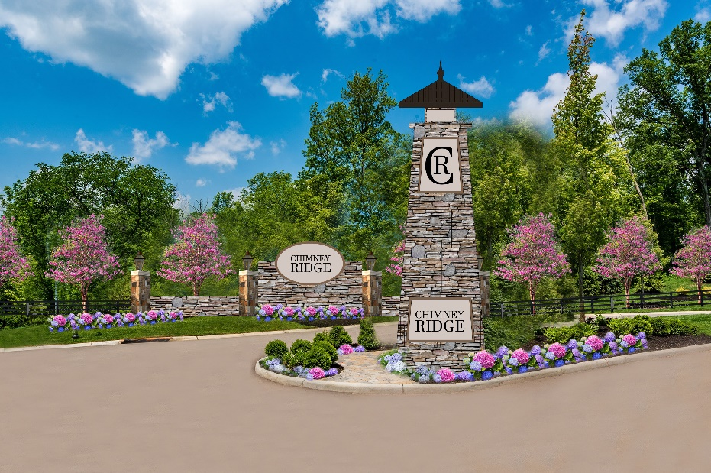
HOMEARAMA® is the registered trade name for the single-site new home showcase produced by the Home Builders Association of Greater Cincinnati. The 2022 show will mark the 59th year for the new home showcase. HOMEARAMA® regularly attracts thousands of enthusiastic Cincinnatians. HOMEARAMA® 2022 will feature six (6) fully decorated and landscaped homes in a variety of architectural styles. Builders include AR Homes; Drees Homes; Eagle Custom Homes, Inc.; J & K Custom Homes, LLC; Redknot Homes; and, WP Land Company, LLC. The homes will be priced at $750,000 to over 1M.

ChimneyRidge, presented by the Campbell-Berling partnership, sits high on 26 wooded acres off of Butterworth Road in the City of Loveland. It is located in Warren County and is part of the Little Miami School District. ChimneyRidge is limited to 30 homesites which many back up to private, wooded and sloping rear yards with lots up to two acres. A gas lit front entry with natural stone walls lends an old-world charm to the former homestead of Civil War Union General Thomas Tinsley Heath. The three cul-de-sac streets cut among the old growth trees of ChimneyRidge place residents less than a mile from the shops and restaurants of historical downtown Loveland and its widely recognized Bike Trail. Neighboring communities including Milford, Madeira and Montgomery offer additional shopping and dining options. ChimneyRidge offers easy access to I-275 and is a short drive to Kenwood Towne Center, Kings Island, Western & Southern Open at the Mason Tennis Center, Oasis Golf Club, O’Bannon Creek Golf Club and much, much more!
Show Dates/Hours
Dates - Saturday, June 11th - Sunday, June 26th
Hours - Monday – Thursday 4:00 PM – 9:00 PM; Friday – Sunday 12:00 Noon – 9:00 PM

Ticket Prices
Tickets are $20.00 at the gate. Discount tickets are available online at www.cincyhomearama.com or on the Cincinnati HOMEARAMA® app for $19.00. A special TWO-DAY ticket will be available for $30.00 at the gate only. Children 12 and under are admitted for free if accompanied by an adult. No tickets sold or admittance to the show after 8:00 PM.

Directions
From I-275 North or South, Take Exit 52 Loveland/Indian Hill. Turn Left onto Loveland-Madeira Road, right onto West Loveland Avenue, left onto State Route 48, left onto Butterworth Rd then a right into ChimneyRidge and follow signs to HOMEARAMA® parking.
GPS Address – 10377 Butterworth Road, Loveland, OH 45140

Important Show Information
There is no charge for parking as the ticket price includes on-site parking. Parking is located on a grass field with gravel drive lanes. The HBA, HOMEARAMA® or the developer are not responsible for valuables that are left in cars, muddy cars or muddy shoes. If it is raining, or if it has rained for a considerable amount of time, you can assume that the grass field will be muddy and you should plan accordingly.

Delicious food, beer and wine will be available at HOMEARAMA®. And, in addition, historic downtown Loveland restaurants and bars will be offering some very enticing HOMEARAMA® specials. A restroom trailer and a handicap accessible portable restroom will be available on site. Numerous events are being planned for HOMEARAMA® 2022. All events will be listed on the HOMEARAMA® website www.cincyhomearama.com.

No strollers, wagons or child backpacks with metal frames are permitted in the show homes. No pets are permitted within the show site, except for service animals (documentation is required for service animals). We suggest that you wear gym shoes or flat shoes to HOMEARAMA®. There is a considerable amount of walking at the show and there are steps in most of the homes.

HomeZone Exhibit Tent
Check out the newest home products in the HomeZone Exhibit Tent at the entrance to the show which will include over 20 vendors.




HOMEARAMA® is produced by the Home Builders Association of Greater Cincinnati
11260 Chester Road, Suite 800, Cincinnati, OH 45246
Phone (513) 851-6300 • Fax (513) 589-3211
www.cincybuilders.com
For HOMEARAMA® information visit www.cincyhomearama.com

