2021 FACT SHEET

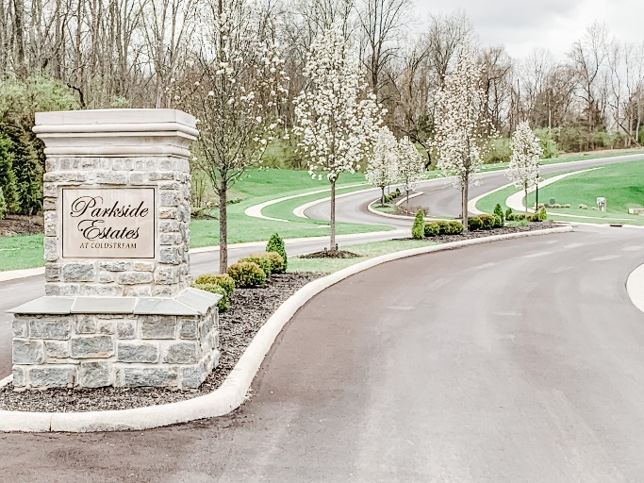
HOMEARAMA® is the registered trade name for the single-site new home showcase produced by the Home Builders Association of Greater Cincinnati. The 2021 show will mark the 58th year for the new home showcase. HOMEARAMA® regularly attracts thousands of enthusiastic Cincinnatians. HOMEARAMA® 2021 will feature five (5) fully decorated and landscaped homes in a variety of architectural styles. The homes will start at $1M.

Developed by Coldstream Area Development, LLC/Zicka Homes Inc., Parkside Estates boasts 48 half-acre lots that sit amongst a wooded hamlet, gifting owners with tranquility and natural beauty within close proximity of the central city. It is located within the desirable highly acclaimed Forest Hills School District. There is ample shopping and entertainment nearby including the Anderson Town Centre, Eastgate Mall, Jungle Jim's International Market, and it is not far from Kenwood Towne Center or Crestview Hills Town Center. Parkside Estates offers easy access to I-275. It is just minutes from Coney Island Amusement Park, Riverbend Music Center, Belterra Park Cincinnati, Coldstream Country Club, The Banks in downtown Cincinnati, Newport on the Levee, OTR and much, much more!
Show Dates/Hours
Dates - Saturday, June 12th - Sunday, June 27th
Hours - Monday – Thursday 4:00 PM – 10:00 PM; Friday – Sunday 12:00 Noon – 10:00 PM

Ticket Prices
Tickets are $19.00 at the gate, on the Cincinnati HOMEARAMA® app or online at www.cincyhomearama.com. Discount tickets are available at area Kroger stores for $17.00. A special TWO-DAY ticket will be available for $29.00 at the gate only. Children 12 and under are admitted for free if accompanied by an adult. No tickets sold or admittance to the show after 9:00 PM.

Directions
From I-275 heading South, Take exit 65 for OH-125 Beechmont Ave./Amelia. Turn right on OH-125, turn left on Eight Mile Road, turn right on Hopper Road, turn left onto Parkside Lake Drive and follow signs to HOMEARAMA® parking.

From I-75 South, I-71 South to I-471 South to I-275 heading East, Take Exit 71 for US-52 East toward New Richmond. Turn left onto Asbury Road, turn right onto Hopper Road, turn right onto Parkside Lake Drive and follow signs to HOMEARAMA® parking.

GPS Address – 8010 Parkside Lake Drive, Cincinnati, OH 45255

Important Show Information
There is no charge for parking as the ticket price includes on-site parking. Parking is located on a grass field with gravel drive lanes. The HBA, HOMEARAMA® or the developer are not responsible for valuables that are left in cars, muddy cars or muddy shoes. If it is raining, or if it has rained for a considerable amount of time, you can assume that the grass field will be muddy and you should plan accordingly.

Concessions by Vonderhaar’s Catering will be available at the HOMEARAMA® Café at Parkside Estates. Restrooms are available on site. Numerous events are being planned for HOMEARAMA® 2021. All events will be listed on the HOMEARAMA® website www.cincyhomearama.com.

No strollers, wagons or child backpacks with metal frames are permitted in the show homes. No pets are permitted within the show site, except for service animals. We suggest that you wear gym shoes or flat shoes to HOMEARAMA®. There is a considerable amount of walking at the show and there are steps in most of the homes.

HomeZone Exhibit Tent
Check out the newest home products in the HomeZone Exhibit Tent at the entrance to the show which will include over 25 vendors.

HOMEARAMA® is produced by the Home Builders Association of Greater Cincinnati
11260 Chester Road, Suite 800, Cincinnati, OH 45246
Phone (513) 851-6300 • Fax (513) 589-3211
www.cincybuilders.com
For HOMEARAMA® information visit www.cincyhomearama.com

